Portion of the site plan
- Logo

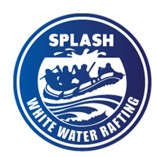
- Color labels
primary-color: #14110F
secondary-color: #003249
accent1-color: #90E0EF
accent2-color: #00B4D8
- Font labels
heading-font: Russo One
text-font: Funnel Sans
- URL link of the color palette
https://coolors.co/00b4d8-90e0ef-003249-14110f

